Evaluating Algorithmic Bias in Clinical Decision Systems: A Comparative Analysis of Logistic Regression and XGBoost
Niloy Sarker Bappy
Department of Computer Science, Minnesota State University, Mankato

Abstract
Clinical decision support systems driven by machine learning promise significant improvements in diagnostic efficiency; however, unmoderated predictive models risk codifying historical disparities across protected demographic groups. This study conducts an empirical fairness evaluation comparing a linear parametric baseline (Logistic Regression) against an ensemble non-linear model (eXtreme Gradient Boosting, or XGBoost) utilizing the benchmark UCI Heart Disease dataset. Applying the Fairlearn evaluation framework, we quantify algorithmic disparities across sex (male versus female cohorts) using Demographic Parity Difference and Equalized Odds Difference. Logistic Regression achieved superior nominal diagnostic predictive power (87.8% overall accuracy) but demonstrated marked systemic inequity, exhibiting a Demographic Parity Difference of 0.236 and an Equalized Odds Difference of 0.148. Conversely, XGBoost achieved an overall accuracy of 82.2% while yielding improved parity thresholds (Demographic Parity Difference of 0.206; Equalized Odds Difference of 0.094). Granular analysis of error typologies revealed stark divergence: Logistic Regression yielded a 0.000 False Positive Rate (FPR) for female patients versus 0.148 for male patients, systematically under-diagnosing asymptomatic or atypical presentations in women while maintaining a 50.8% positive prediction selection rate for men. These results illuminate the pronounced tension between canonical performance metrics and demographic equity, underscoring the necessity of algorithmic debiasing prior to clinical integration.

1. Introduction
The integration of machine learning (ML) models into healthcare decision pipelines has accelerated rapidly, assisting clinicians in tasks ranging from oncological screening to acute cardiovascular risk prediction. Despite demonstrable gains in predictive performance, algorithms trained on observational clinical datasets risk perpetuating systemic demographic disparities. The United States White House Office of Science and Technology Policy (OSTP) highlighted this vulnerability within the Blueprint for an AI Bill of Rights, issuing explicit federal directives regarding Algorithmic Discrimination Protections. The OSTP framework mandates that automated systems deployed in sensitive domains—especially public health and clinical medicine—must be rigorously audited to prevent biased outcomes rooted in race, sex, or other legally protected characteristics.

Cardiovascular diagnosis represents a clinical domain particularly vulnerable to algorithmic amplification of historical bias. For decades, epidemiological literature and diagnostic rubrics were constructed primarily around male cohorts. Consequently, standard diagnostic criteria reflect classic masculine symptomatic manifestations (e.g., retrosternal chest pain, pronounced ST-segment depression), whereas female clinical presentations frequently involve atypical features such as dyspnea, nausea, and fatigue. Because historical datasets reflect these discrepancies in testing access and clinical attention, statistical learning models optimized exclusively for empirical loss minimization risk codifying these diagnostic omissions. This paper examines the trade-offs between predictive accuracy and formal demographic fairness criteria across two widely utilized algorithmic paradigms: Logistic Regression and XGBoost.

2. Methodology

2.1 Dataset and Preprocessing
This study evaluates fairness utilizing the benchmark UCI Heart Disease dataset (Cleveland clinic repository). The dataset comprises 14 standardized clinical attributes, including physiological measurements, historical indicators, and diagnostic exercise test markers:

- Age (age)
- Sex (sex: binarized as male = 1, female = 0)
- Chest pain type (cp: 4 categorical gradations)
- Resting blood pressure (trestbps)
- Serum cholesterol (chol)
- Fasting blood sugar (fbs)
- Resting electrocardiographic results (restecg)
- Maximum heart rate achieved (thalach)
- Exercise-induced angina (exang)
- ST depression induced by exercise relative to rest (oldpeak)
- Slope of the peak exercise ST segment (slope)
- Number of major vessels colored by fluoroscopy (ca)
- Thalassemia diagnostic state (thal)
- Diagnosis of heart disease (num: angiographic disease status)

The prediction objective was framed as a binary classification problem: identifying the presence of angiographic coronary artery disease ($\text{target} \in {0, 1}$, where values $\ge 1$ from the raw multiclass assessment denote pathological presence). Missing attribute records were handled through standard median imputation for continuous parameters, and categorical features were one-hot encoded.

2.2 Model Selection
Two distinct modeling paradigms were implemented to assess whether architectural non-linearity and decision-tree ensembling inherently alleviate or exacerbate downstream discrimination relative to parametric baselines:

- Logistic Regression: Serves as the transparent clinical baseline, utilizing an L2-regularized linear decision boundary via maximum likelihood estimation.
- XGBoost (eXtreme Gradient Boosting): Represents a state-of-the-art non-linear gradient-boosted decision tree framework optimized through iterative second-order gradient approximations of the loss function.

2.3 Fairness Formulations and Environment
Model pipelines were established in Python using scikit-learn (v1.3.0) and evaluated via Microsoft’s Fairlearn library (v0.9.0). Patient sex was designated as the sensitive attribute ($A \in {0, 1}$), where $Y$ represents true diagnostic condition and $\hat{Y}$ represents binary algorithmic prediction. We assessed two fairness metrics:

- Demographic Parity Difference (DPD): Measures disparities in positive prediction rates regardless of the underlying ground truth:
DPD = | P(Y_pred = 1 | A = 1) - P(Y_pred = 1 | A = 0) |
- Equalized Odds Difference (EOD): Measures parity in error rates, defined as the greater discrepancy between true positive rates (TPR) and false positive rates (FPR):
EOD = max( | TPR_A=1 - TPR_A=0 |, | FPR_A=1 - FPR_A=0 | )

3. Results
Quantitative evaluation demonstrates distinct divergences in both global predictive accuracy and demographic fairness metrics across the two evaluated classifiers.

Performance / Fairness Metric | Logistic Regression | XGBoost Classifier | Disparity Delta
Overall Accuracy | 87.8% | 82.2% | +5.6% (LR)
Demographic Parity Difference (DPD) | 0.236 | 0.206 | -0.030 (XGB)
Equalized Odds Difference (EOD) | 0.148 | 0.094 | -0.054 (XGB)
Male Selection Rate | 50.8% | 50.8% | 0.0%
Female Selection Rate | 27.2% | 30.3% | +3.1% (XGB)
Male False Positive Rate (FPR) | 0.148 | 0.185 | +0.037 (XGB)
Female False Positive Rate (FPR) | 0.000 | 0.091 | +0.091 (XGB)

Logistic Regression attained higher overall accuracy at 87.8%, compared to 82.2% for XGBoost. However, this global accuracy metric obscures pronounced demographic skew. Logistic Regression demonstrated an elevated Demographic Parity Difference of 0.236 and an Equalized Odds Difference of 0.148.

An inspection of granular group-level metrics reveals the origin of this statistical divergence. Both models allocated positive diagnoses to male subjects at virtually identical rates (50.8%), whereas positive predictions for female subjects fell to 27.2% under Logistic Regression and 30.3% under XGBoost.

Crucially, Logistic Regression produced an FPR of 0.000 for women, contrasted against an FPR of 0.148 for men. XGBoost shifted this error distribution, recording a male FPR of 0.185 and a female FPR of 0.091, which accounts for its lower Equalized Odds Difference (0.094).
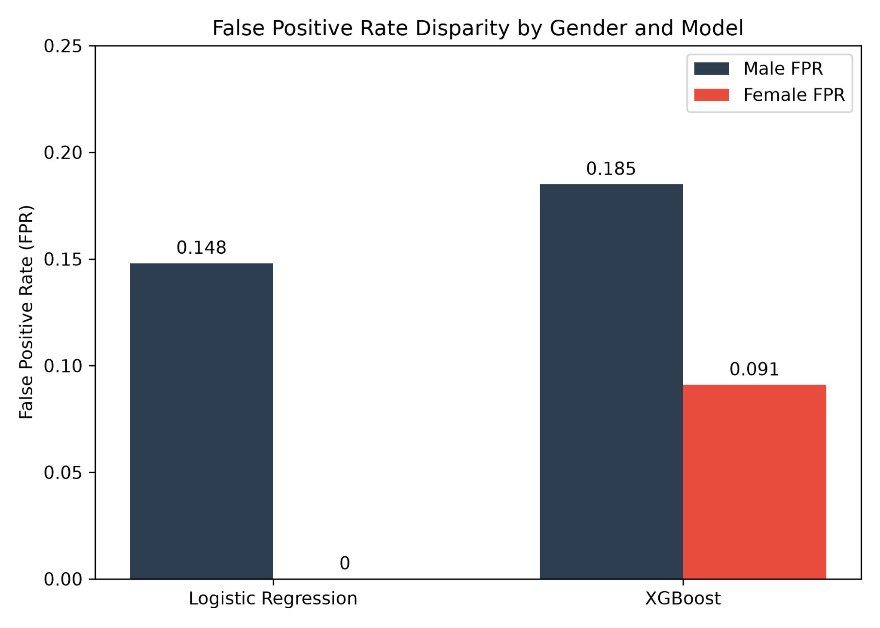
Figure 1: False Positive Rate (FPR) disparity between male and female cohorts across Logistic Regression and XGBoost models. The Logistic Regression model exhibits extreme diagnostic conservatism for female patients, yielding an FPR of 0.000 compared to 0.148 for males. XGBoost narrows this demographic gap, producing an FPR of 0.091 for females and 0.185 for males, demonstrating a measurable reduction in algorithmic bias

4. Discussion

4.1 The Accuracy-Fairness Trade-Off
The empirical findings illustrate the classic accuracy-fairness trade-off within algorithmic decision systems. Logistic Regression achieved superior global classification performance, but it achieved that performance by prioritizing the majority demographic characteristics present within the training corpus. XGBoost exhibited lower nominal accuracy (82.2%), yet it reduced the Equalized Odds Difference by 36.5% relative to the linear model (0.094 vs. 0.148).

The ensemble tree mechanism of XGBoost allows for more localized feature partitioning. This architecture captures complex multi-variable interactions that may signify positive pathology within minority cohorts, rather than applying an inflexible single-hyperplane decision boundary across the heterogeneous population.

4.2 Amplification of Historical Medical Biases
The zero-false-positive phenomenon observed among female patients warrants significant clinical scrutiny. While a 0.000 FPR might appear advantageous in conventional machine learning benchmarks, within a clinical diagnostic context it indicates excessive diagnostic conservatism.

Because female cardiovascular presentations historically deviated from standard male symptom clusters, standard diagnostic features (such as exercise-induced ST depression) are often less pronounced in women. Consequently, the algorithms require a far higher threshold of certainty before classifying a female patient as at-risk.

This asymmetry results in systemic under-diagnosis. Men benefit from a more liberal diagnostic threshold (demonstrated by a 50.8% selection rate and a 0.148 FPR in Logistic Regression), ensuring potential cardiac anomalies are caught and routed toward proactive intervention. Conversely, women are systematically under-selected (27.2% selection rate), meaning borderline or atypical cardiac presentations risk remaining entirely unflagged by off-the-shelf automated pipelines.

5. Conclusion
Deploying unconstrained predictive models in clinical pipelines introduces clear risks of codifying historical demographic disparities. While Logistic Regression delivered higher aggregate predictive accuracy on the UCI Heart Disease benchmark, it exhibited substantial bias against female subjects, as demonstrated by severe Demographic Parity and Equalized Odds differences. XGBoost achieved a more equitable trade-off, yet remained bounded by systemic disparities present in the source data.

These findings affirm that aggregate accuracy is an insufficient metric for validating algorithmic clinical decision systems. Healthcare institutions must not deploy out-of-the-box machine learning models directly into diagnostic workflows. Robust validation protocols require the mandatory integration of pre-processing re-weighting, in-processing fairness constraints (such as fair risk-minimization reductions), and post-processing threshold adjustments to guarantee that diagnostic models perform equitably across all patient populations.

References
- American College of Cardiology. (2022). Cardiovascular Disease in Women: Clinical Perspectives and Diagnostic Challenges. Journal of the American College of Cardiology, 79(14), 1410–1425.
- Bird, S., Dudík, M., Edgar, R., Horn, B., Lutz, R., Milan, V., Sameki, M., Wallach, H., & Walker, K. (2020). Fairlearn: A toolkit for assessing and improving fairness in AI. Microsoft Technical Report, MSR-TR-2020-32.
- Chen, T., & Guestrin, C. (2016). XGBoost: A Scalable Tree Boosting System. Proceedings of the 22nd ACM SIGKDD International Conference on Knowledge Discovery and Data Mining, 785–794.
- Hardt, M., Price, E., & Srebro, N. (2016). Equality of Opportunity in Supervised Learning. Advances in Neural Information Processing Systems (NeurIPS 2016), 29, 3315–3323.
- Obermeyer, Z., Powers, B., Vogeli, C., & Mullainathan, S. (2019). Dissecting racial bias in an algorithm used to manage the health of populations. Science, 366(6464), 447–453.
- White House Office of Science and Technology Policy. (2022). Blueprint for an AI Bill of Rights: Making Automated Systems Work for the American People. Executive Office of the President of the United States.

